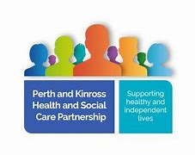
Perth and Kinross Integration Joint Board
Service User Public Partner

Nomination Form
You are invited to join the Reference Group meeting for a conversation of why you would like to stand as a public partner. The meeting is on 24th February 2021 via online teams from 10am-12noon and a link will be sent to you.

Name
Contact Telephone
Contact Email
Address
Please tell us why you should be appointed to the role of Service User Public Partner
(max 500 words)

These words will appear on the election form for voting by the Reference Group
Please return the nomination form to communityengagement@pkc.gov.uk by 17th February 2021

